**ECE 311 - Lab 2**

*Shadman Kaif*

25/11/2020

**1 - INTRODUCTION**

In this section, you will summarize the main purpose of this lab and briefly describe the experiments you performed.

**2 - EXPERIMENTS**

In this section you will report all your experimental simulation: discuss your hypothesis and results.

**2.1 OPEN LOOP RESPONSE**

Include here the open loop response (position and velocity) of your cart to periodic square wave input.

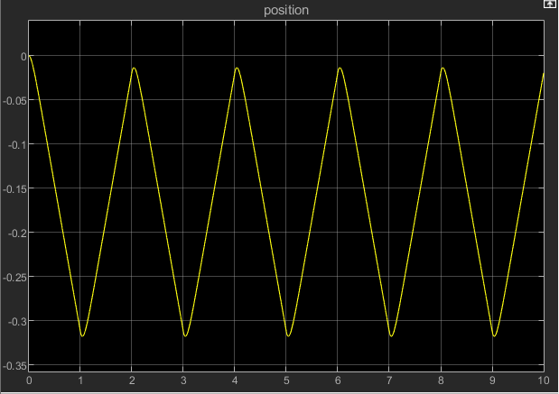

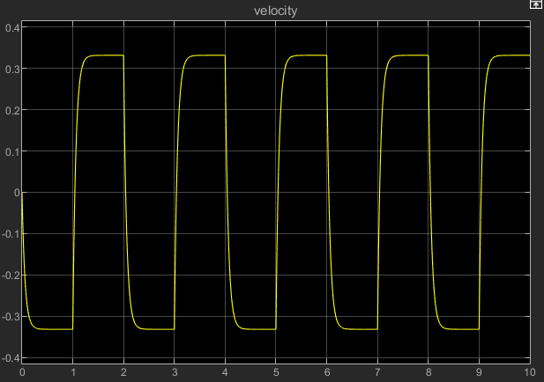

**2.2 IDENTIFICATION OF MODEL**

In this section you will discuss about your estimation of the parameters *a* and *b.*

Be sure to include the following material and discussions:

1. The plot showing the response for your initial guess for the parameters *a* and *b*

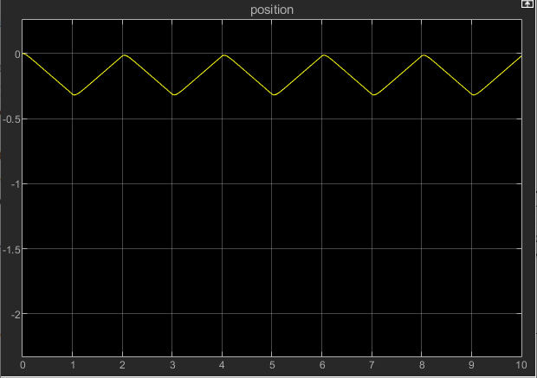

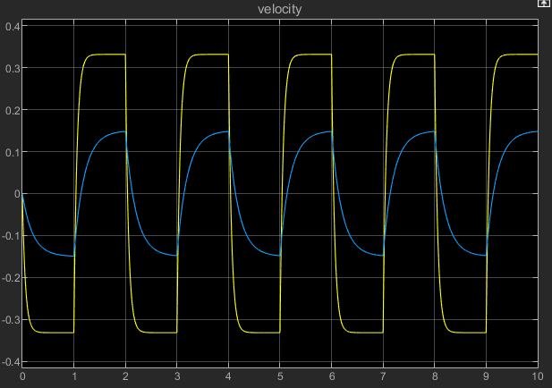

1. The derivation of the expression *a=f(b)* (check the lab instructions), including the plots where you measure the output variation 𝚫*v*

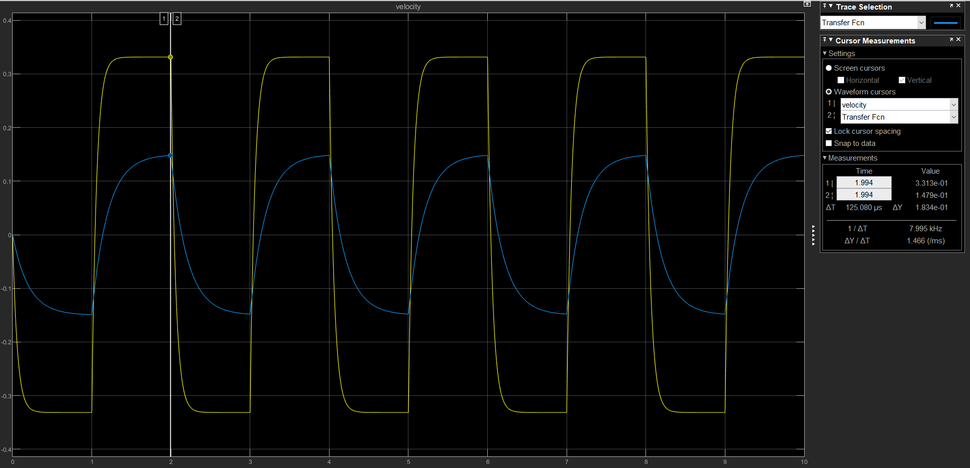

As we can see with the above plot, the output variation is the peak to peak for the velocity plot. By tracing, we get the peak to be 0.3313. The output variation, 𝚫*v*, is 0.6626.

Knowing this, we can find the relationship between a and b.

0.6626= 3 $(\frac{a}{b}$)

a = (0.221)b

1. The final choices for *a* and *b* and the corresponding plot response

Final choice for a and b is:

a = 3.757

b = 17

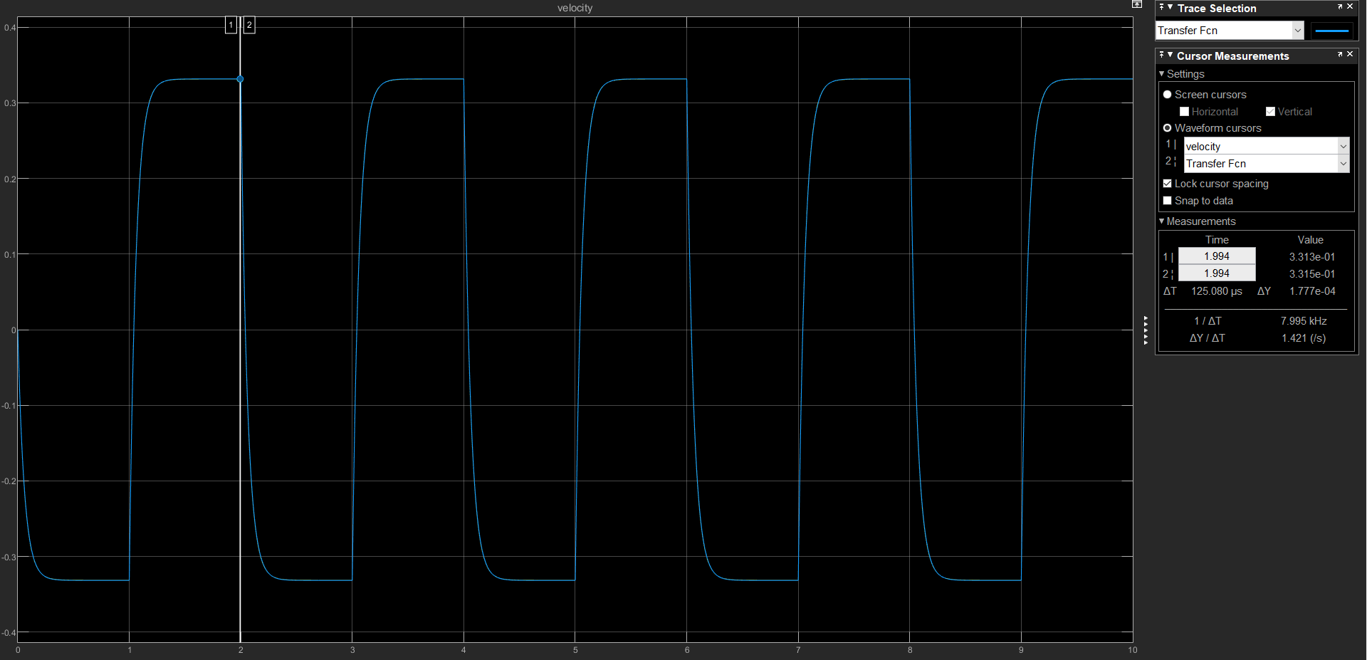

**2.3 PROPORTIONAL CONTROL**

In this section you will discuss about your findings regarding the proportional controller.

Be sure to include the following material and discussions:

1. Your hypothesis about the asymptotic tracking performances with a P controller

I hypothesize that as the gain controller, K, increases, the steady state error decreases. E(s) = $\frac{V_{0}(s+b)}{s(Ka+s+b}$, and if we apply Final Value Theorem, we get $e_{ss}$ = $\frac{V_{0}b}{Ka+b}$. Since K is in the denominator, this leads me to believe that the steady state error decreases as K increases.

1. The first closed loop response for your closed loop system with *K=5*

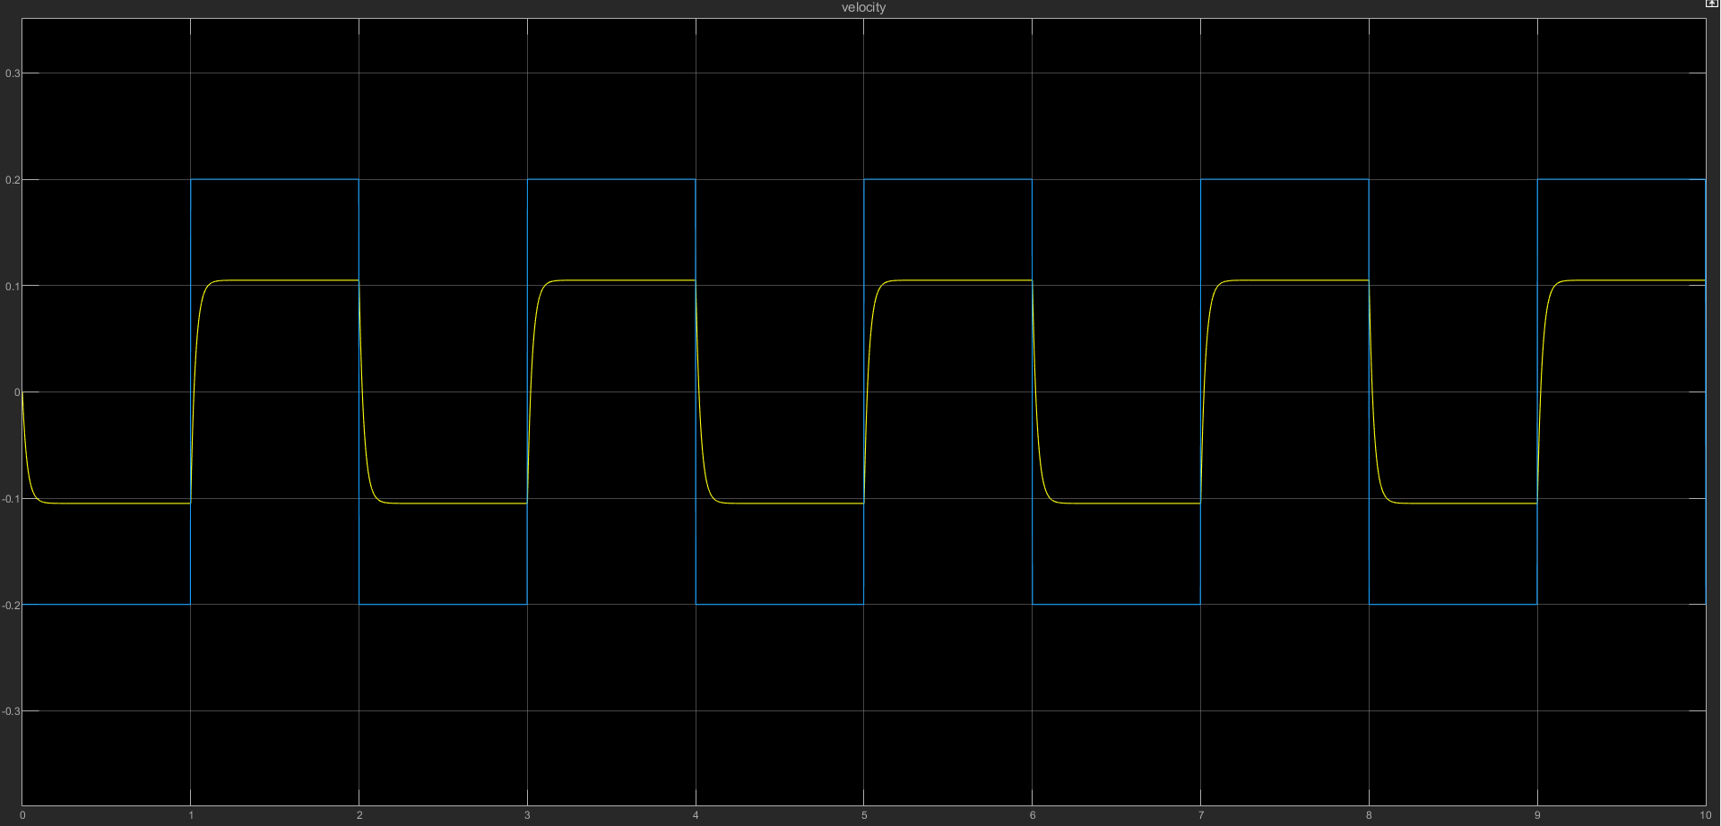

1. Your comments about the matching of the experimental data and initial theoretical hypothesis

Since the gain of 5 is a low number, we see a huge discrepancy between the plots of the velocity and Signal Generator.

1. Your hypothesis about the effect of an increasing controller gain *K*

As we increase the controller gain K, the discrepancy between the plots of the velocity and Signal Generator will minimize and get smaller.

1. Two more plots for increasing values of *K*

For value of K=10:

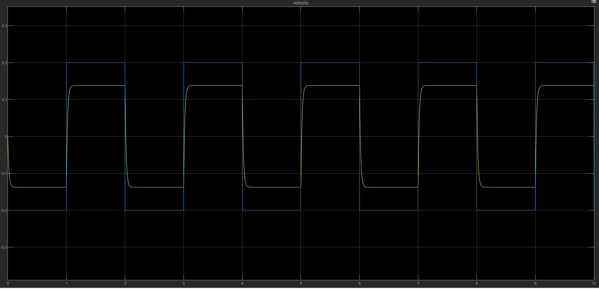

For value of K=20:

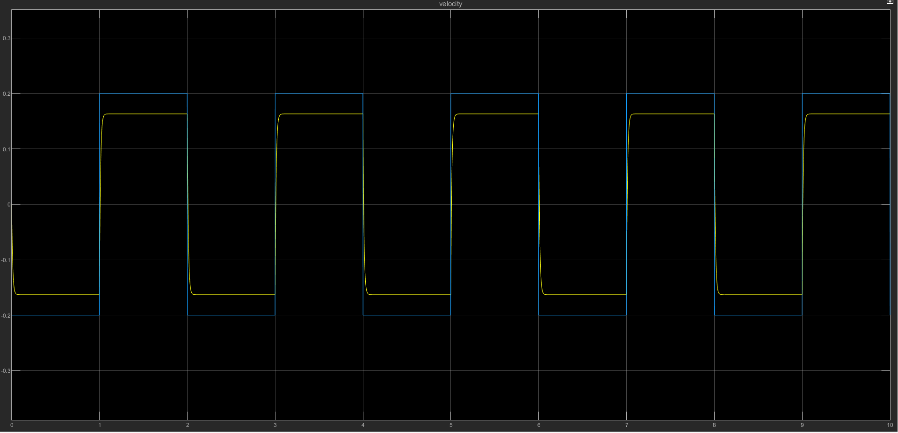

1. Your final considerations about the effect of an increasing *K*

We can safely deduce that the effect of an increasing K is the minimizing of the steady state error between the velocity and Signal Generator. We can see as we increase the gain controller, K, from 5 to 10, the steady state error decreases. Steady state error further decreases when increasing K from 10 to 20 as observed in the plots included.

**2.4 PROPORTIONAL-INTEGRAL CONTROL**

In this section you will include the following material and discussions:

1. Your first simulation plots with the proposed values of *K* and *T_i*

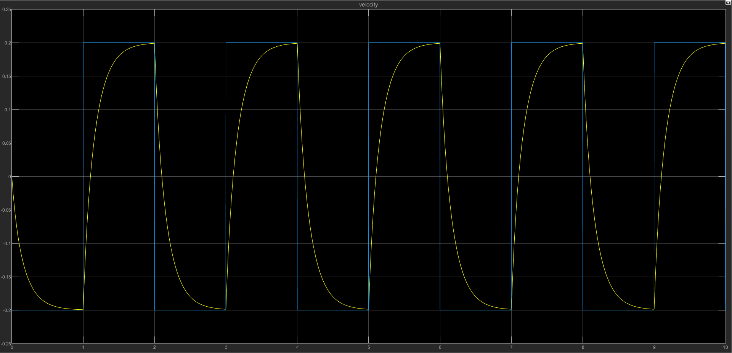

1. Two more plots for increasing values of *K*

For K=5:

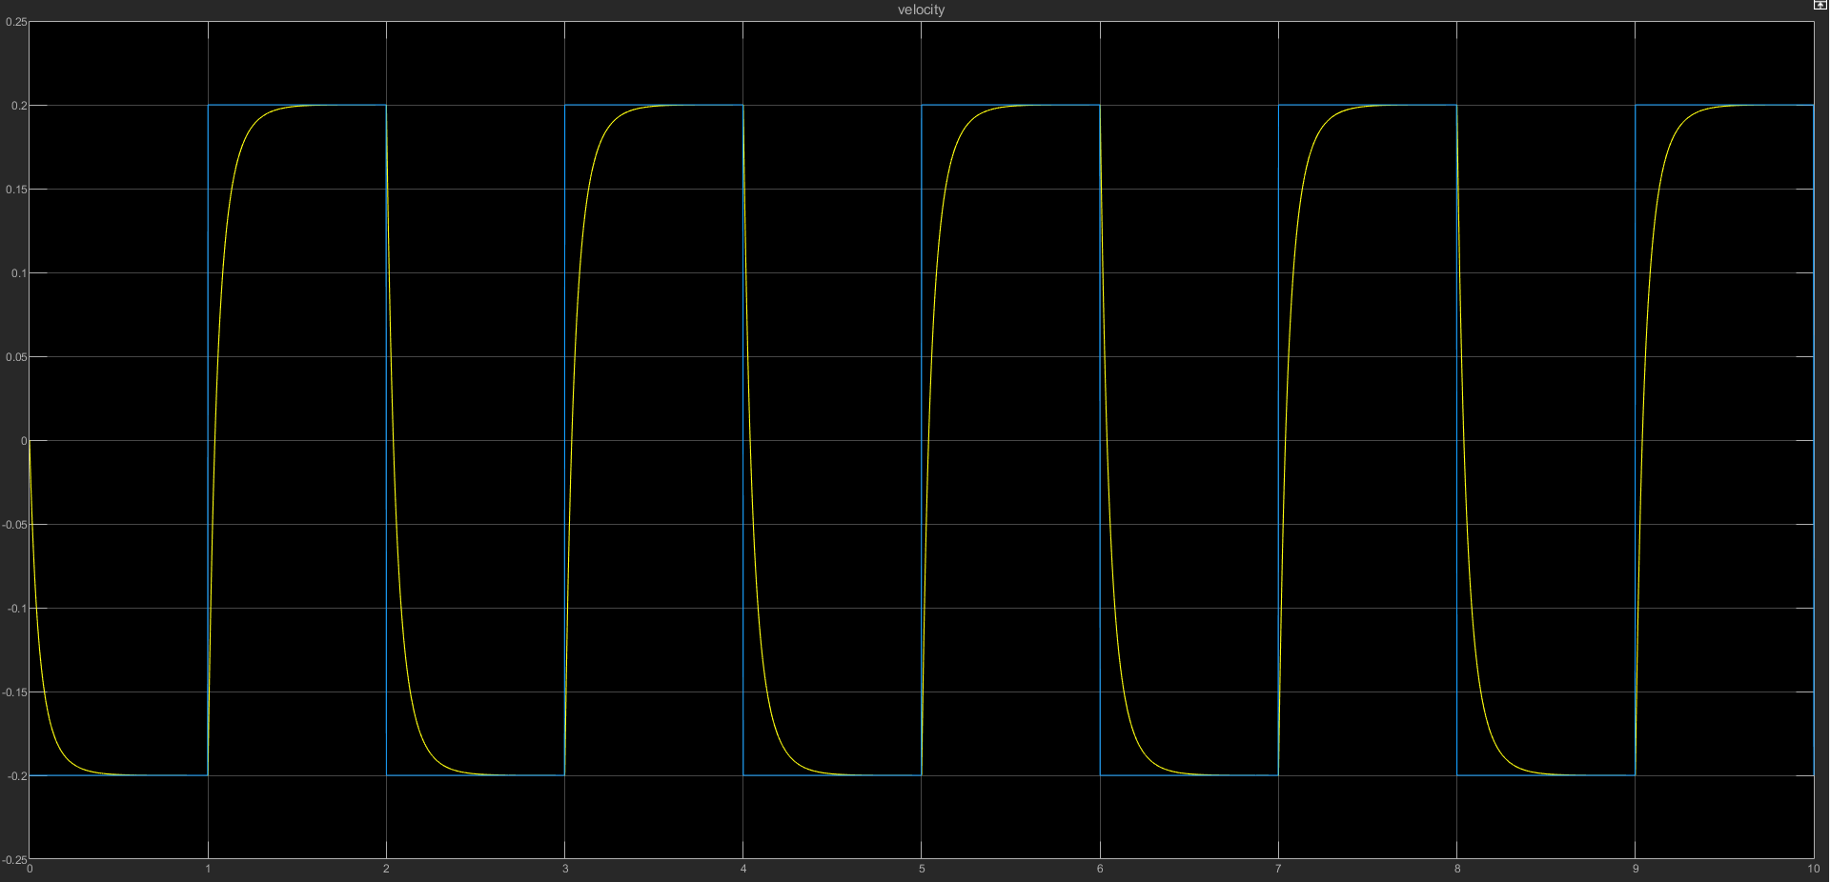

For K=20:

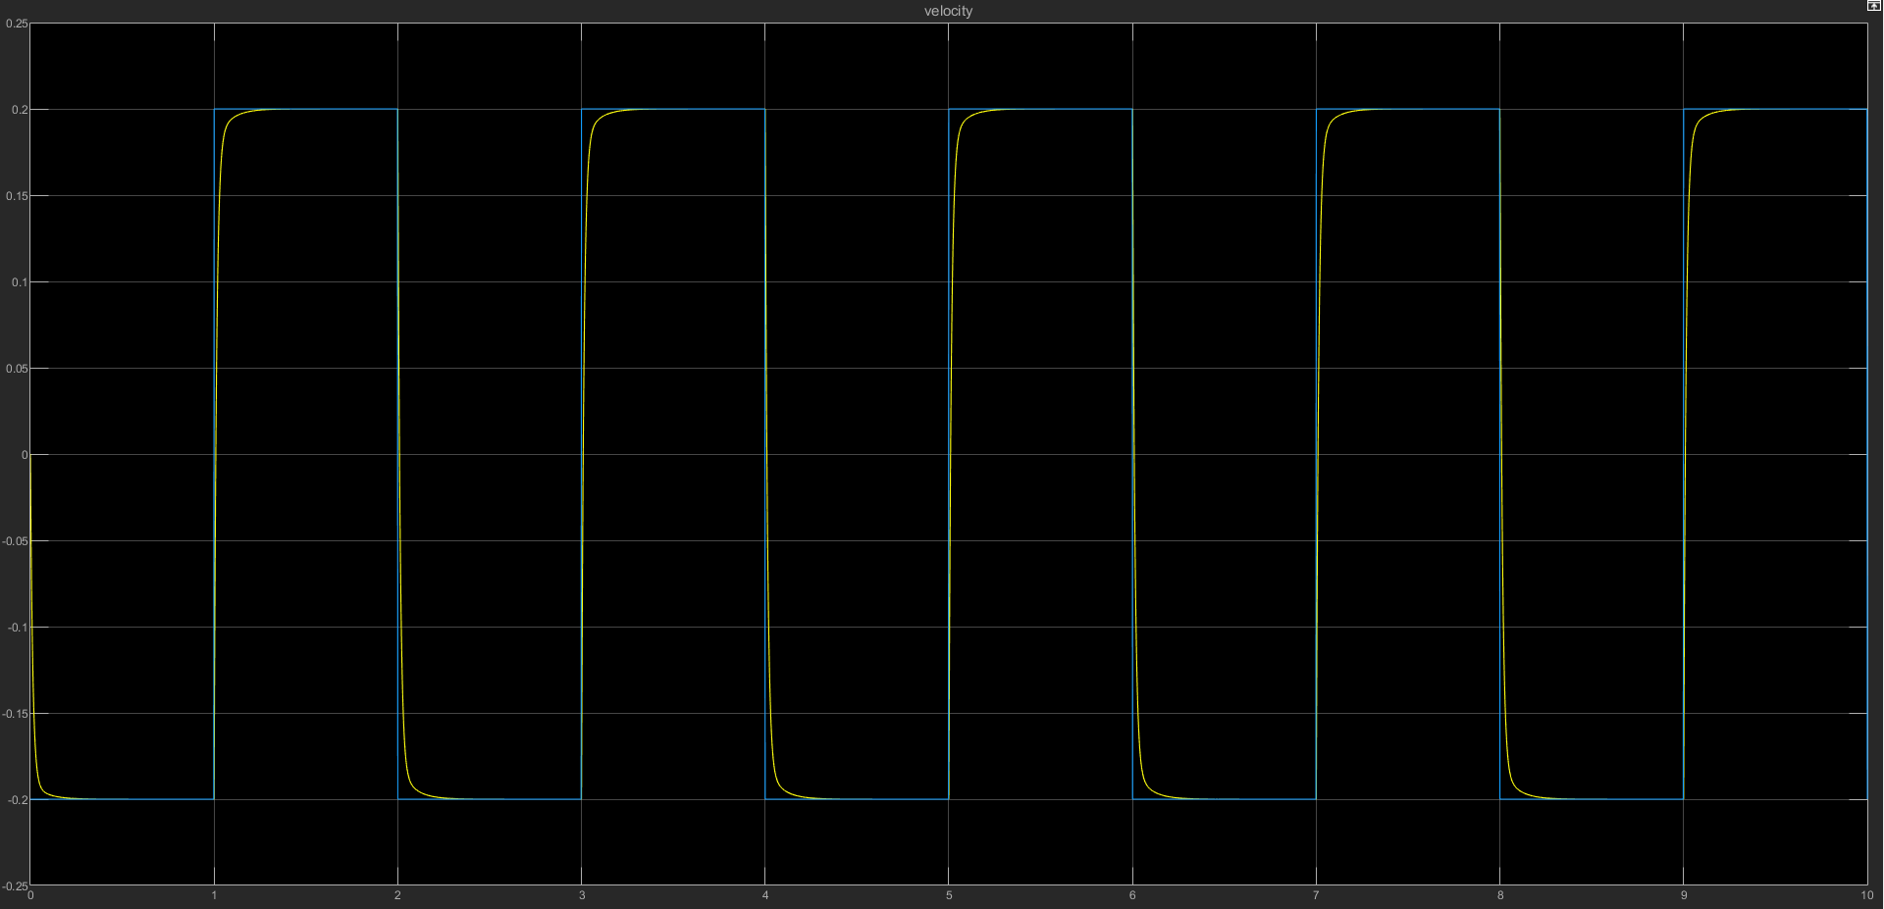

1. Discuss about the effect of an increasing *K*

For the PI controller, E(s) = $\frac{T_{i}V_{0}}{T_{i}s+K(T_{i}s+1)}$. If we apply Final Value Theorem, we get $e_{ss}$ = 0 for any value of K. Thus, steady state error approaches 0 regardless of K’s value. However, increasing the value of K decreases the time taken to reach the steady state’s appraoch to 0. This gives us the chance to track the Signal Generator better.

**3 - CONCLUSIONS**

In this section you need to answer the following questions:

1. How does changing the control parameters affects the closed loop performance?

For the P controller, increasing the K value decreases the steady state error. As calculated before, K is in the denominator of the steady state error when using Final Value Theorem. Thus, as K approaches infinity, the steady state error will approach 0, and as a result, the plot will be very similar to the Signal Generator square wave signal. However, for the PI controller, the steady state error approaches 0 regardless of K’s value. Increasing the K value simply decreases the time taken for the steady state error to approach 0, which makes it easier to emulate the Signal Generator square wave signal.

1. How does the performance of the P and PI controllers compare?

As we saw with both controllers, the PI controller’s steady state error approaches 0 regardless of K’s value whereas the P controller’s steady state error approaches 0 as K approaches infinity. We can attest this to the integral part of the PI controller eliminating the steady state error. Thus, the PI controller’s performance is better.

1. Which controller is best suited for our objective, i.e. tracking a square wave signal?

The PI controller is certainly best suited for tracking a square wave signal. When comparing the same K value used in both P and PI controllers, the PI controller modelled the square wave signal significantly better. This is evident for K values such as 5 and 20. As mentioned before, the steady state error for the PI controller approaches 0 regardless of K’s value, thus modelling the square wave signal significantly easier than the P controller’s steady state error which requires K approaching infinity.